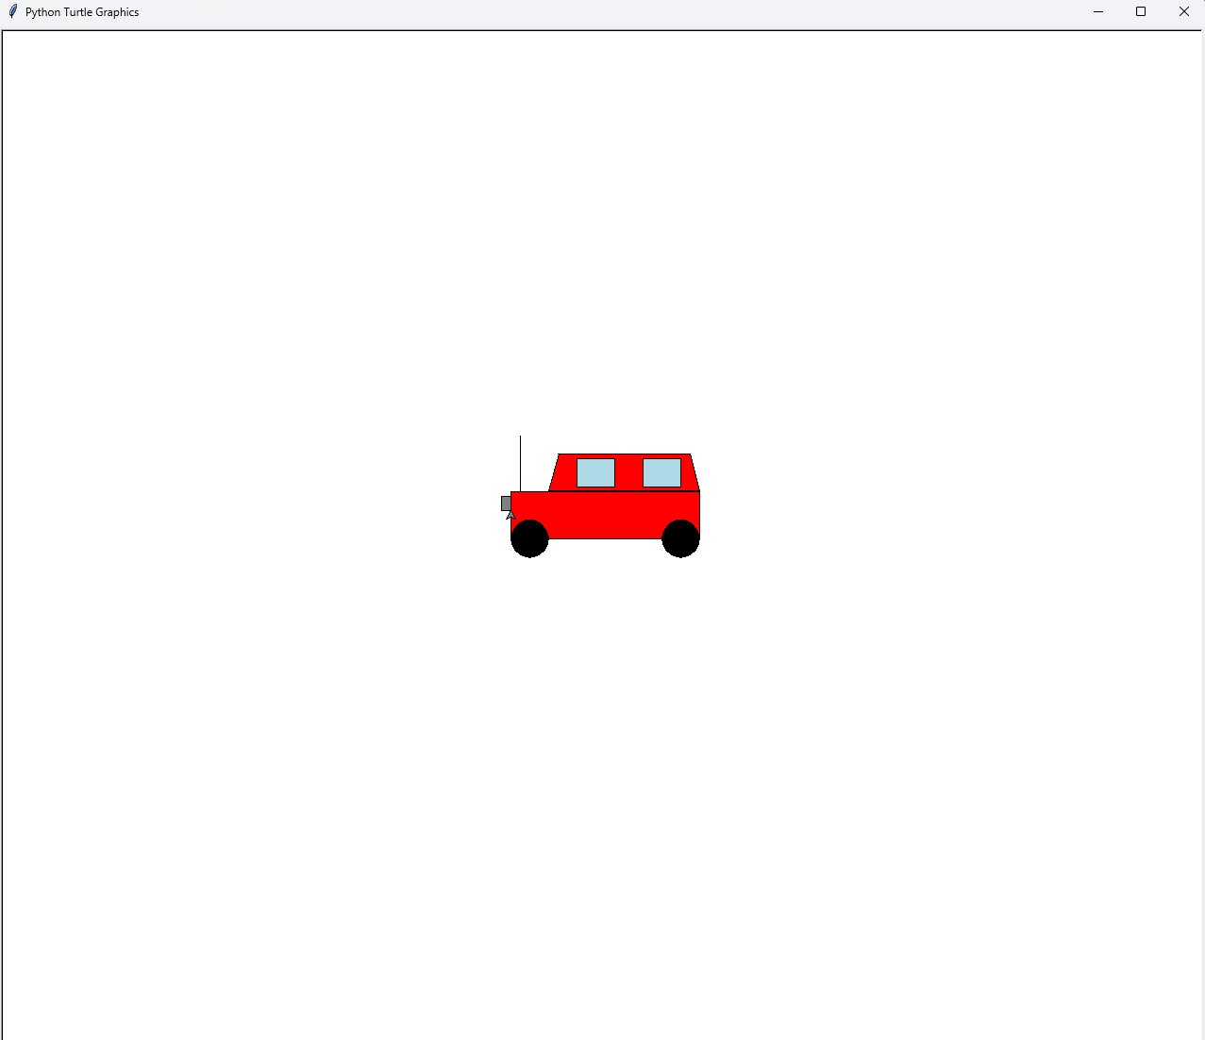

We learned how to utilize the turtle graphics and create designs around it creating what we would call a SUV. Mostly we had a rough time figuring out where to put everything and also figuring out the dimensions. It took a lot of trials to finish the final product. Even then I feel like it could’ve ended a bit better. We could’ve added some more details like better shaped glass on the windshield, but in the end, I just couldn’t figure it out. Last thing We learned was how much work it takes to draw a simple car. I feel we take for granted all the things we see on the internet and while completing this project I felt more appreciation for what people do in the CS industry.

File